**Course: Advance Bio Informatics**

**Module Title: Cell Cycle Key to Drug Discovery**

**Module No: 150**

**Cell Cycle Applications**

**Proliferative disease**

Cell cycle relevance in cell proliferative diseases that are

* Cancer - Is a genetic disease in which a gene mutation transforms the normal cell into abnormal cell.
* Angiogenesis - Development of new blood vessels from pre-existing vessels

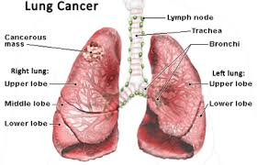

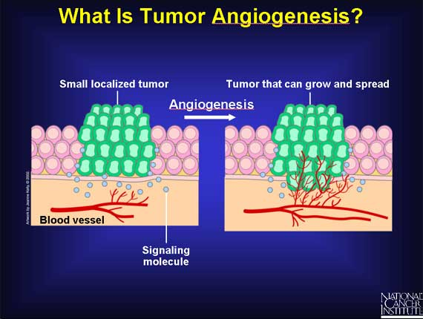

**Cancer Genome Project**

* Searching every human gene for cancer-related disease.
* 30 tumor suppressor and 100 dominant oncogenes (creation of cancer) have been identified.

**Cancer Therapies**

Radiation and chemotherapeutic is the treatment of cancer that cause undesirable side effects due to their failures to categorize between normal and cancer cells.

Most oncologists suggested that to overcome the side effects by finding new and efficacious anticancer drugs based on the identification of the cell cycle targets.